**Basics of Convolutions**

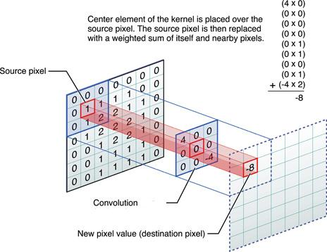

**Fig:** Process of convolution

1. In mathematics, convolution is an operation performed on two functions (f and g) to produce a third function. Convolution is one of the most important operations in signal and [image processing](https://neptune.ai/blog/image-processing-python). It could operate in 1D (e.g. speech processing), 2D (e.g. [image processing](https://neptune.ai/blog/image-processing-python)) or 3D (video processing).
2. In image processing, convolution is the process of transforming an image by applying a kernel over each pixel and its local neighbors across the entire image. The kernel is a matrix of values whose size and values determine the transformation effect of the convolution process.
3. The Convolution Process involves these steps. (1)It places the Kernel Matrix over each pixel of the image (ensuring that the full Kernel is within the image), multiplies each value of the Kernel with the corresponding pixel it is over. (2)Then, sums the resulting multiplied values and returns the resulting value as the new value of the center pixel. (3) This process is repeated across the entire image.
4. As we see in the picture, a 3x3 kernel is convoluted over a 7x7 source image. Center Element of the kernel is placed over the source pixel. The source pixel is then replaced with a weighted sum of itself and surrounding pixels. The output is placed in the destination pixel value. In this example, at the first position, we have 0 in source pixel and 4 in the kernel. 4x0 is 0, then moving to the next pixel we have 0 and 0 in both places. 0x0 is 0. Then again 0x0 is 0. Next at the center there is 1 in the source image and 0 in the corresponding position of kernel. 0x1 is 0. Then again 0x1 is 0. Then 0x0 is 0 and 0x1 is 0 and at the last position it is -4x2 which is -8. Now summing up all these results we get -8 as the answer so the output of this convolution operation is -8. This result is updated in the Destination image.
5. The output of the convolution process changes with the changing kernel values. For example, an Identity Kernel shown below, when applied to an image through convolution, will have no effect on the resulting image. Every pixel will retain its original value as shown in the following figure.

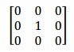

**Fig:** Identity Kernel

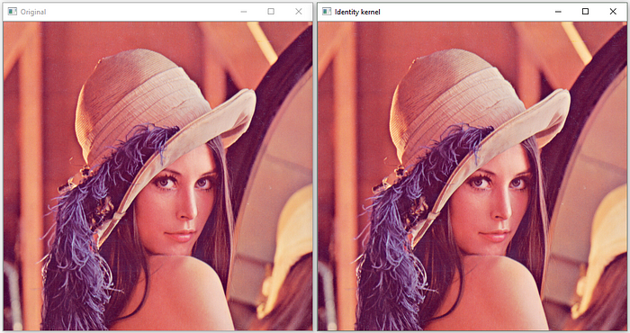

**Fig:** Original Image(Left) and Image after applying Identity Filter of size 3x3(Right)

A Sharpen Kernel like this when applied to an image through convolution, will have an image sharpening effect to the resulting image. The precise values can be customized for varying levels of sharpness as shown in the following figure.

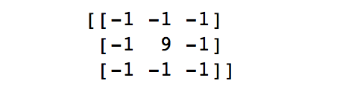

**Fig:** Sharpen Kernel

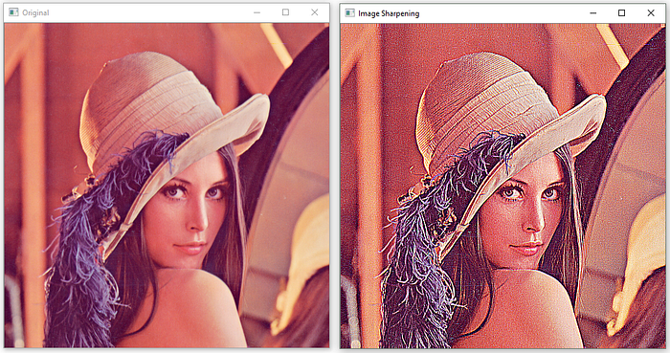

**Fig:** Original Image(Left) and Image after applying Sharpen Filter of size 3x3 (Right)

The Gaussian Blur Kernel like this when applied to an image through convolution, will apply a Gaussian Blurring effect to the resulting image.

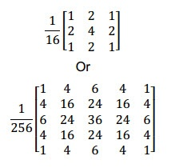

**Fig:** Gaussian Blur Kernel

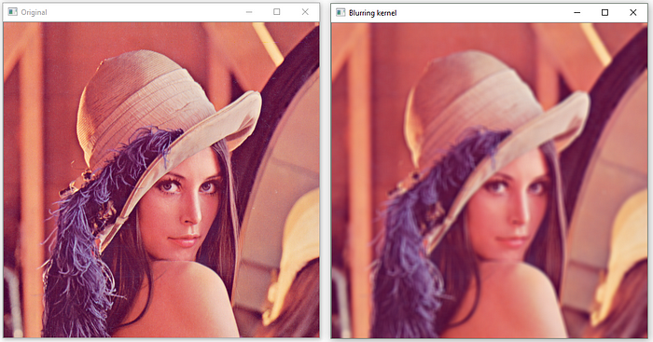

**Fig:** Original Image(Left) and Image after applying Blurring Filter of size 7x7 (Right)

Just as how the values of the Kernel can be varied for different levels of effects, the size of the Kernel can also be altered to shape the effect of the convolution. By increasing the size of the Kernel Matrix, the spatial locality influencing each pixel’s resulting value is increased as pixels from further away are being pulled into the equation. There are many more Kernels that are used in image processing such as edge detection, embossing, rotation, etc.

6. Convolution is the key concept in Convolutional Neural Networks. Convolutional Neural Networks (CNN) are a type of Deep Neural Network. A CNN comprises of Convolutional Layer, Pooling Layer, and Fully-Connected Layer. At the Convolution layer, a CNN applies convolution on to its inputs using a Kernel Matrix that it calibrates through training. For this reason, CNNs are very good at feature matching in images and object classification. The convolution layer parameters consist of a set of learnable kernels. Every kernel is small matrix that extends through the full depth of the input volume. During the forward pass, we convolve each kernel across the width and height of the input image and compute dot products between the pixel values of the source and kernel at corresponding positions.